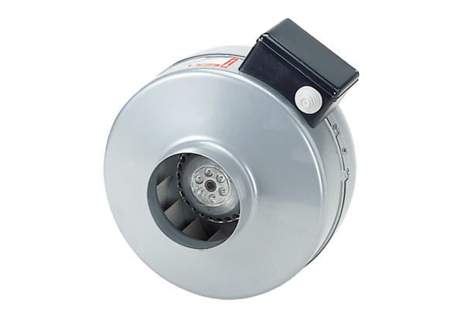Centrifugal duct fan ERR 25/1Packing unit: 1 pieceRange: C
Article number: 0080.0277Manufacturer: MAICO

