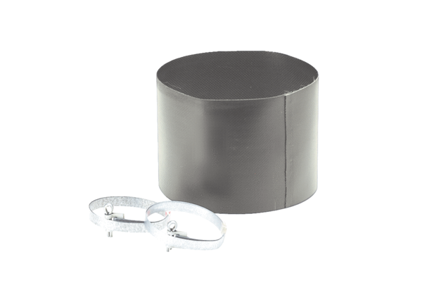Flexible cuff ELM 18Packing unit: 1 pieceRange: C
Article number: 0092.0158Manufacturer: MAICO

