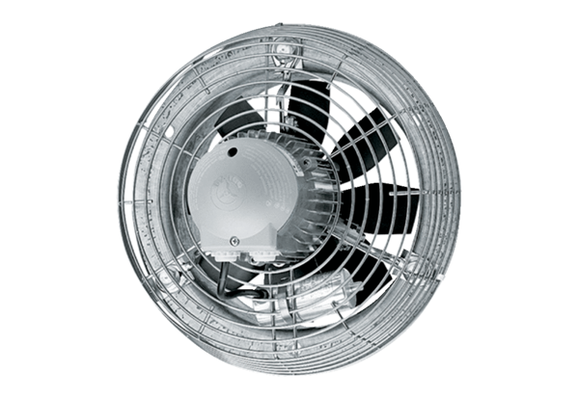Axial wall fan EZS 30/6 BPacking unit: 1 pieceRange: C
Article number: 0094.0002Manufacturer: MAICO

