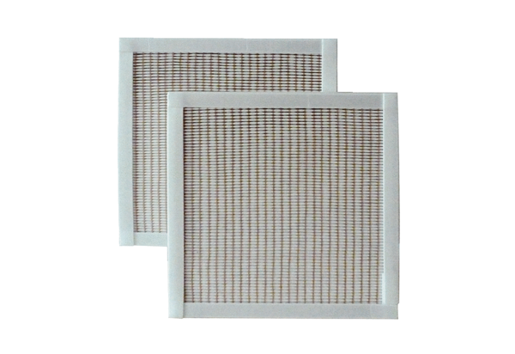Air filter, replacement RF 10/16-5Packing unit: 2 piecesRange: C
Article number: 0093.0875Manufacturer: MAICO

