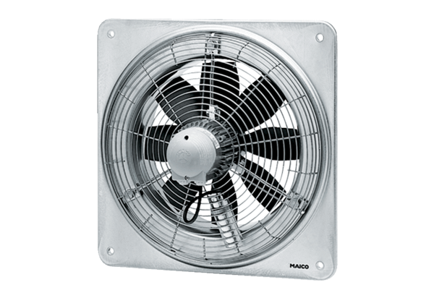Axial wall fan EZQ 30/6 BPacking unit: 1 pieceRange: C
Article number: 0083.0105Manufacturer: MAICO

