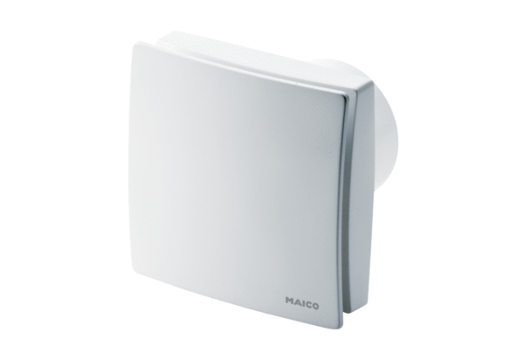Small room fan ECA 150 ipro KBPacking unit: 1 pieceRange: A
Article number: 0084.0096Manufacturer: MAICO

