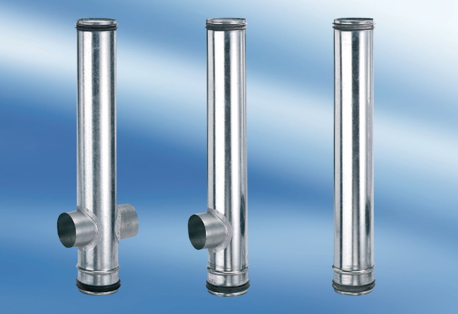BA 140/80-1Packing unit: 1 pieceRange: B
Article number: 0093.0050Manufacturer: MAICO

