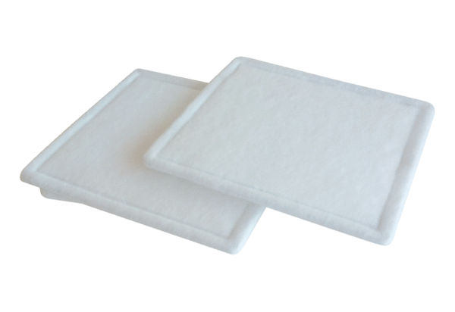Air filter, replacement RF 15-4Packing unit: 2 piecesRange: C
Article number: 0093.0070Manufacturer: MAICO

