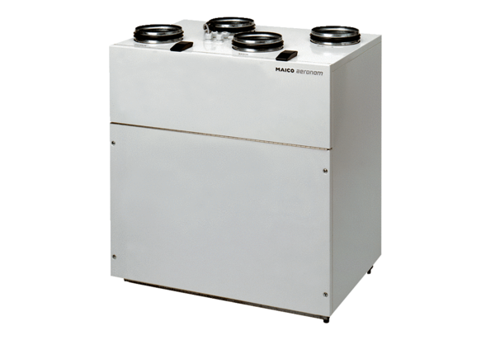Centralised ventilation unit WS 250Packing unit: 1 pieceRange: K
Article number: 0095.0050Manufacturer: MAICO

