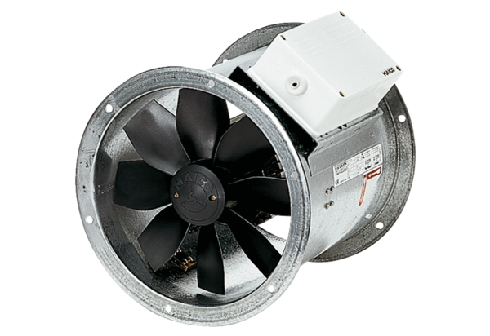Axial duct fan EZR 30/4 BPacking unit: 1 pieceRange: C
Article number: 0086.0004Manufacturer: MAICO

