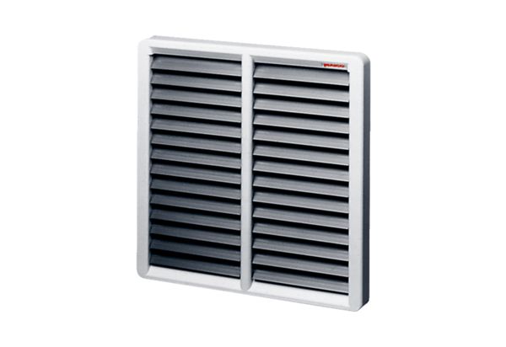Shutter, manual RS 45Packing unit: 1 pieceRange: C
Article number: 0151.0343Manufacturer: MAICO

