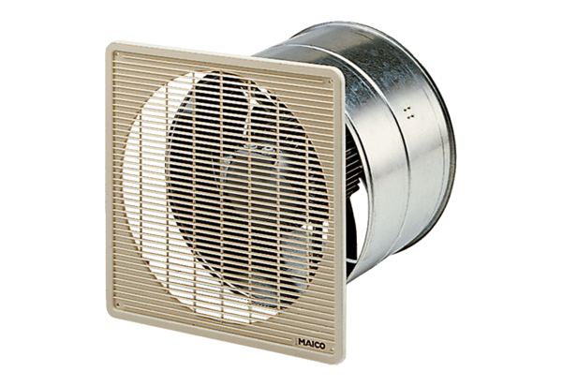DZF 40/6 BPacking unit: 1 pieceRange: C
Article number: 0085.0106Manufacturer: MAICO

