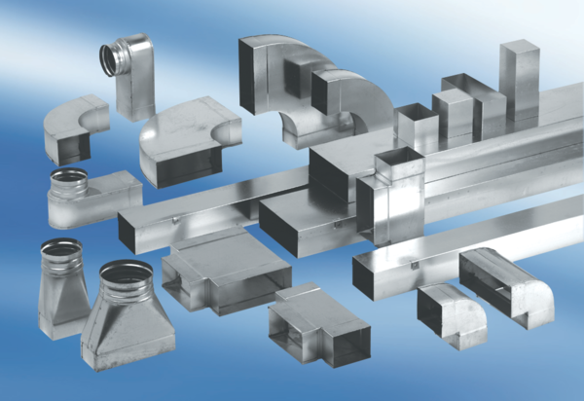45° channel elbows, horizontal KB45H/80/150Packing unit: 1 pieceRange: K
Article number: 0055.0586Manufacturer: MAICO

