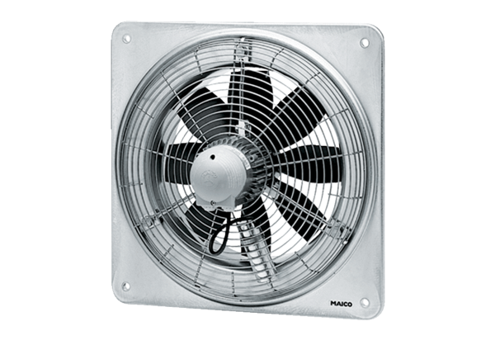Axial wall fan DZQ 50/6 BPacking unit: 1 pieceRange: C
Article number: 0083.0130Manufacturer: MAICO

