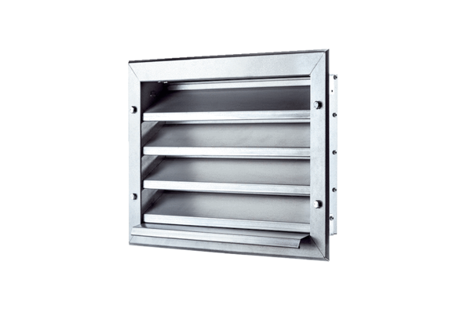External grille LZP 25Packing unit: 1 pieceRange: D
Article number: 0151.0256Manufacturer: MAICO

