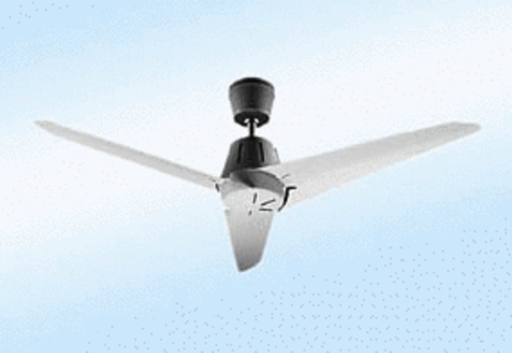Axial ceiling fan EC 90 APacking unit: 1 pieceRange: C
Article number: 0088.0120Manufacturer: MAICO

