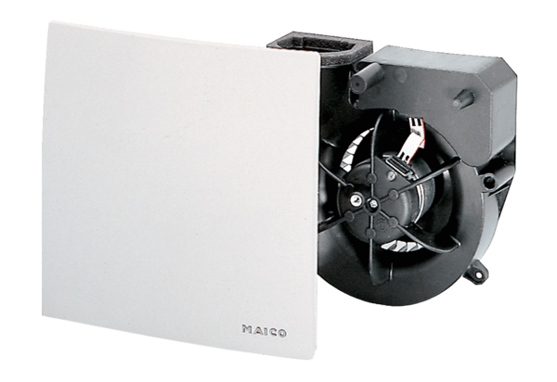Fan insert ER 100 FPacking unit: 1 pieceRange: B
Article number: 0084.0132Manufacturer: MAICO

