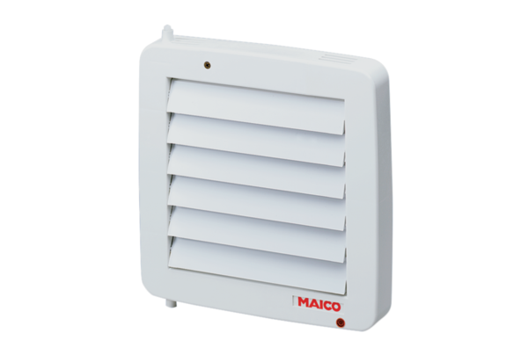Internal shutter, electric AE 16Packing unit: 1 pieceRange: A
Article number: 0151.0302Manufacturer: MAICO

