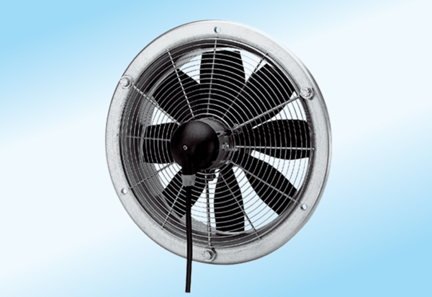Axial wall fan DZS 20/4 A-ExPacking unit: 1 pieceRange: C
Article number: 0094.0101Manufacturer: MAICO

