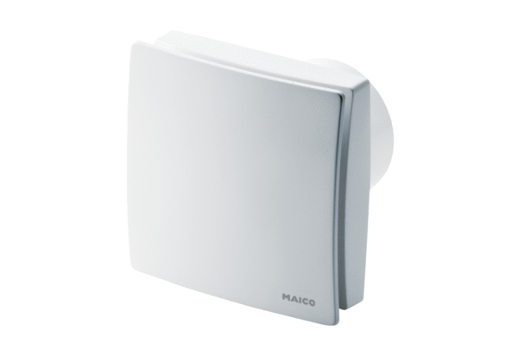Small room fan ECA 150 ipro BPacking unit: 1 pieceRange: A
Article number: 0084.0090Manufacturer: MAICO

