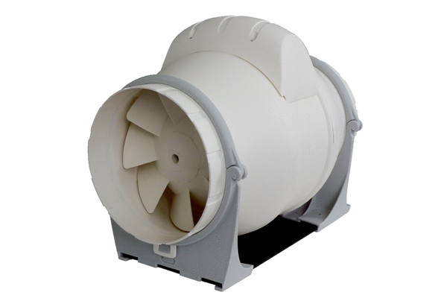Diagonal fan ERK 100 SPacking unit: 1 pieceRange: C
Article number: 0080.0175Manufacturer: MAICO

