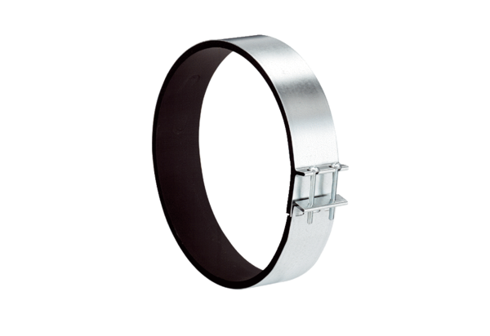Fixing cuff ELR 16Packing unit: 1 pieceRange: C
Article number: 0092.0111Manufacturer: MAICO

