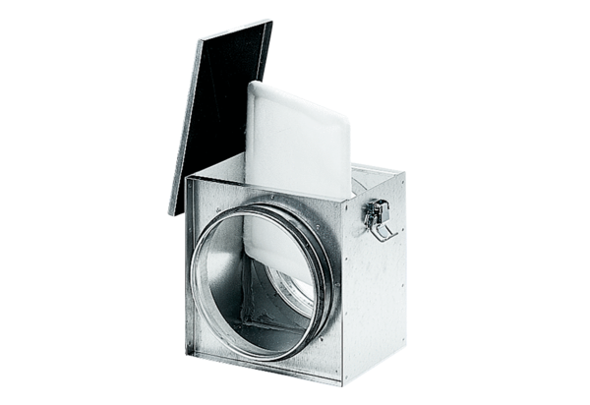Air filter TFE 15-4Packing unit: 1 pieceRange: C
Article number: 0149.0076Manufacturer: MAICO

