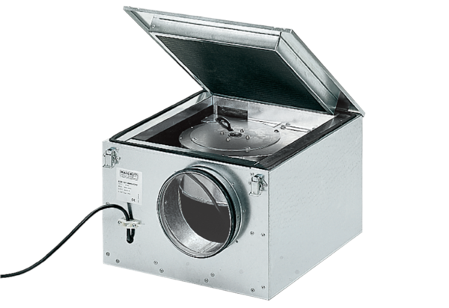Sound-insulated ventilation box ESR 12/1Packing unit: 1 pieceRange: C
Article number: 0080.0281Manufacturer: MAICO

