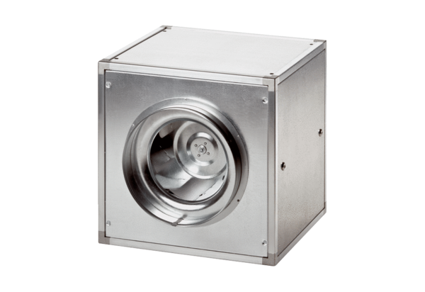Quickbox DSQ 35/4Packing unit: 1 pieceRange: C
Article number: 0080.0034Manufacturer: MAICO

