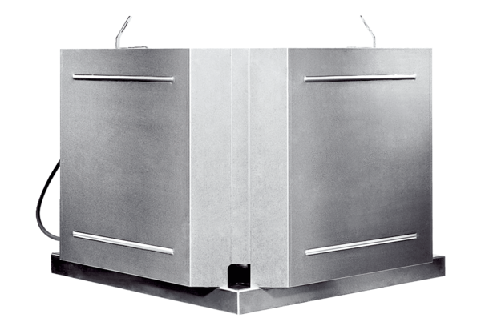Centrifugal roof fan DRD 18 ECPacking unit: 1 pieceRange: E
Article number: 0087.0170Manufacturer: MAICO

