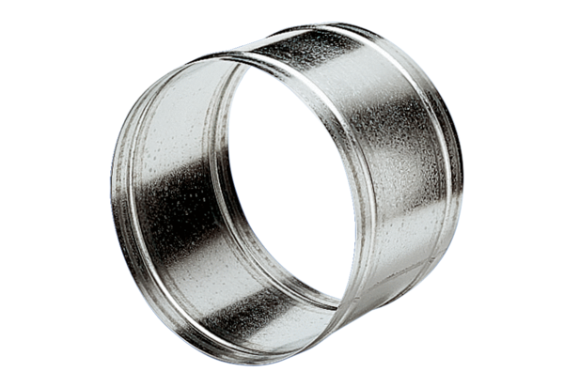Extension sleeve VH 25Packing unit: 1 pieceRange: C
Article number: 0055.0031Manufacturer: MAICO

