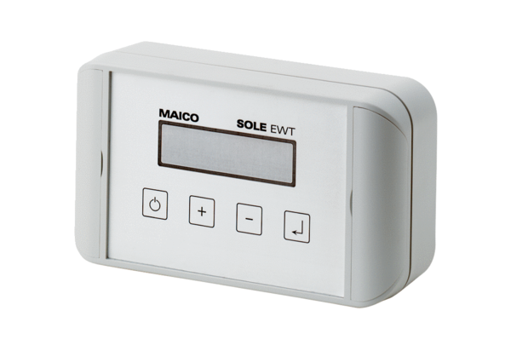Brine pump controller EW-SPacking unit: 1 pieceRange: K
Article number: 0157.0203Manufacturer: MAICO

