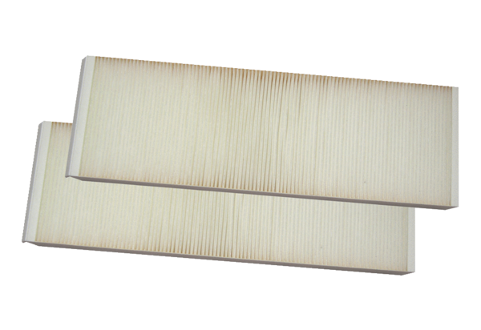Air filter, replacement WSG 320/470Packing unit: 2 piecesRange: K
Article number: 0092.0560Manufacturer: MAICO

