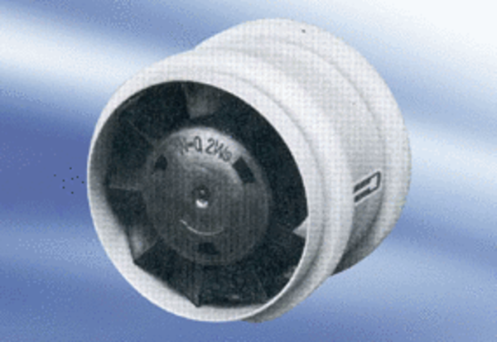Small room fan ECA 9-7Packing unit: 1 pieceRange:
Article number: 080043Manufacturer: MAICO

