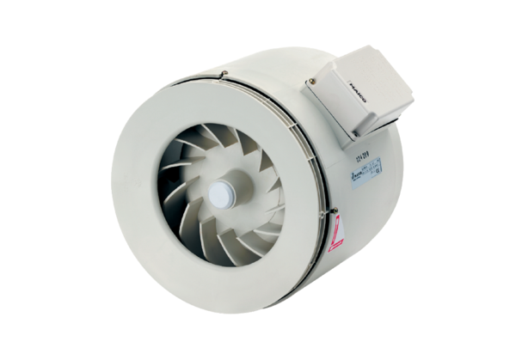Semi-centrifugal duct fan ERM 28Packing unit: 1 pieceRange:
Article number: 0080.0206ALTManufacturer: MAICO

