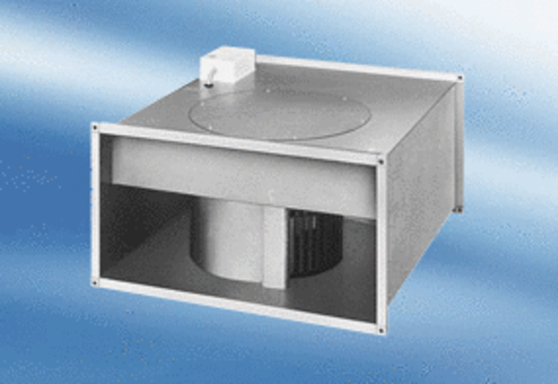Channel fan EPK 25/6 APacking unit: 1 pieceRange:
Article number: 0086.0612Manufacturer: MAICO

