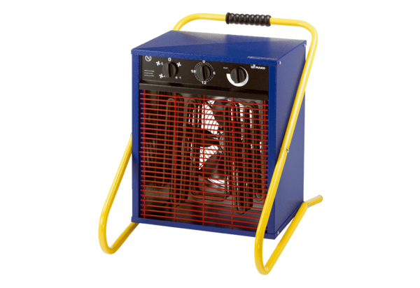Heater fan PHD 20Packing unit: 1 pieceRange: C
Article number: 0082.0069Manufacturer: MAICO

