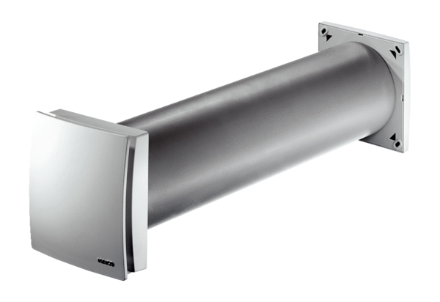Outside air opening ALD 125Packing unit: 1 pieceRange: B
Article number: 0152.0067Manufacturer: MAICO

