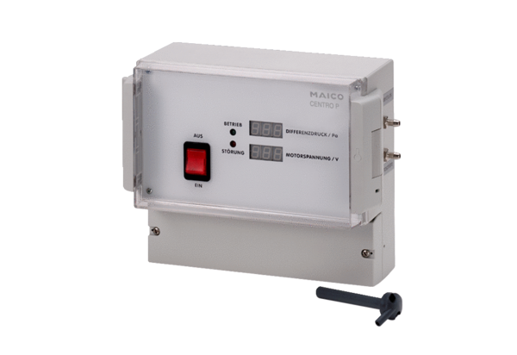Pressure controller Centro-PPacking unit: 1 pieceRange: B
Article number: 0157.0397Manufacturer: MAICO

