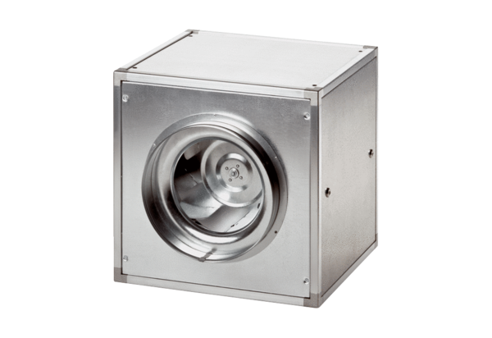Quickbox ESQ 40/4Packing unit: 1 pieceRange: C
Article number: 0080.0030Manufacturer: MAICO

