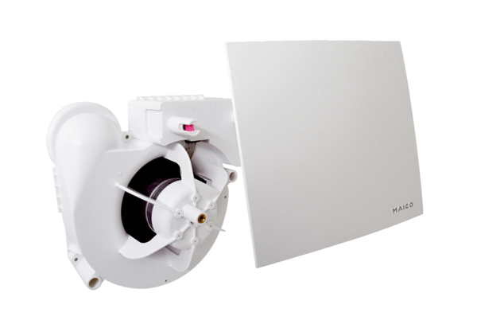Fan insert ER 100 EPacking unit: 1 pieceRange:
Article number: 0084.0380Manufacturer: MAICO

