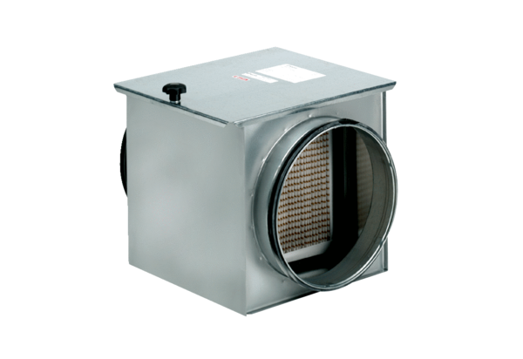Air filter TFE 31-5Packing unit: 1 pieceRange: C
Article number: 0149.0064Manufacturer: MAICO

