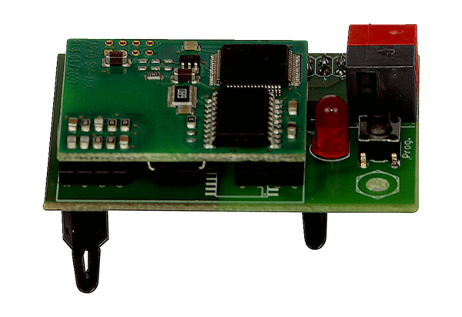KNX plug-in module K-SMPacking unit: 1 pieceRange: K
Article number: 0092.0557Manufacturer: MAICO

