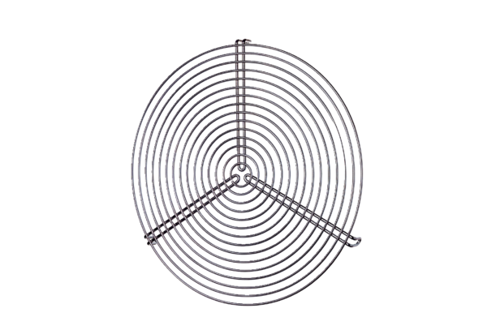Protective grille SGR 20Packing unit: 1 pieceRange: C
Article number: 0150.0126Manufacturer: MAICO

