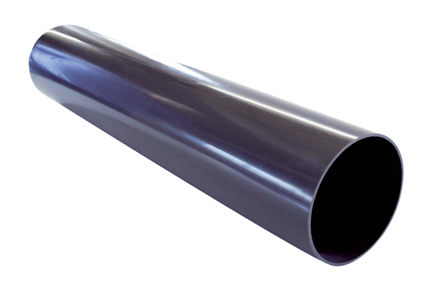Roof outlet sleeve PP 45 DFHLPacking unit: 1 pieceRange: K
Article number: 0059.0869Manufacturer: MAICO

