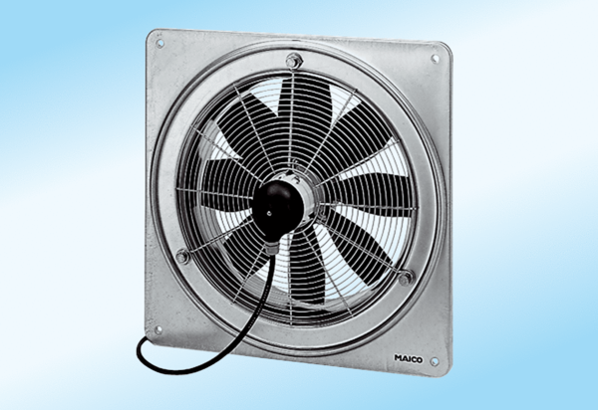Axial wall fan DZQ 35/6 A-ExPacking unit: 1 pieceRange: C
Article number: 0083.0770Manufacturer: MAICO

