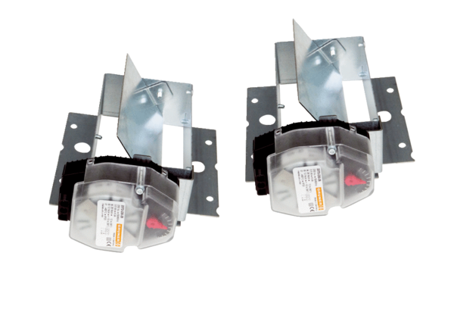Shutters Trio VK QPacking unit: 2 piecesRange: K
Article number: 0017.0229Manufacturer: MAICO

