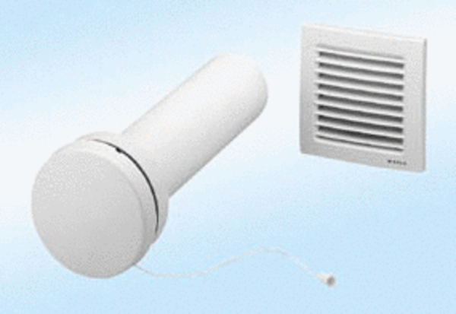Supply air element, uncontrolled ZE8-IZPacking unit: 1 pieceRange:
Article number: 0152.0033Manufacturer: MAICO

