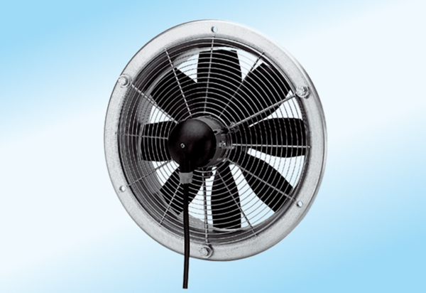Axial wall fan DZS 30/2 A-ExPacking unit: 1 pieceRange: C
Article number: 0094.0107Manufacturer: MAICO

