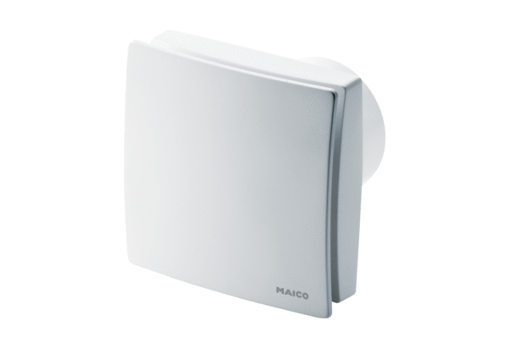Small room fan ECA 150 ipro HPacking unit: 1 pieceRange: A
Article number: 0084.0089Manufacturer: MAICO

