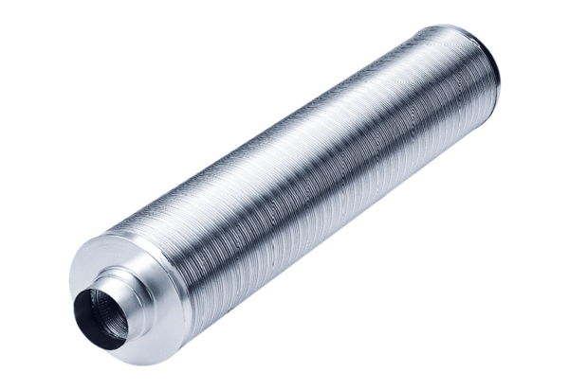Tubular sound absorber RSR 28/50Packing unit: 1 pieceRange: C
Article number: 0092.0328Manufacturer: MAICO

