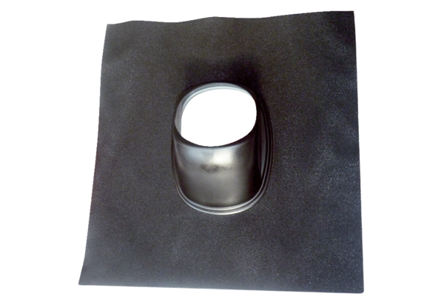Roofing tile DP 125 SBPacking unit: 1 pieceRange: B
Article number: 0092.0379Manufacturer: MAICO

