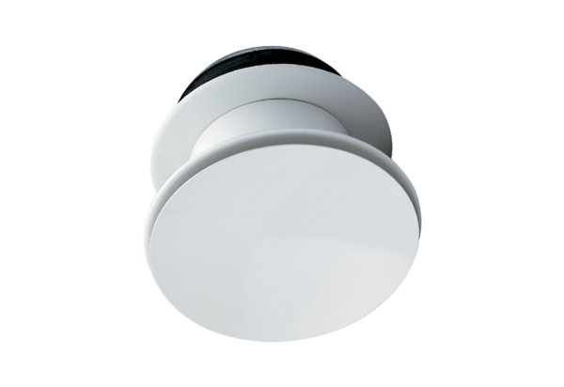Blower nozzle WD 10 DPacking unit: 1 pieceRange: K
Article number: 0151.0291Manufacturer: MAICO

