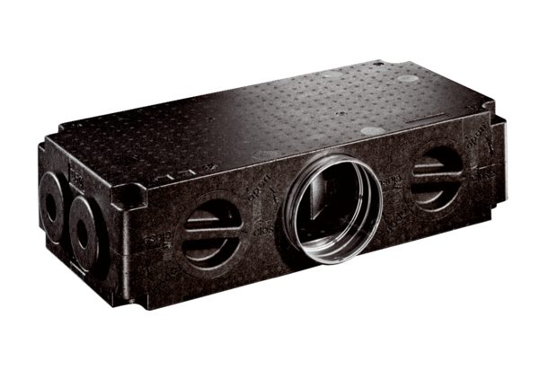Air distributor made of plastic, 8-way MF-V75-8Packing unit: 1 pieceRange: K
Article number: 0059.0980Manufacturer: MAICO

